Insurance Agent Samurai

*Vishal Chauhan, Ajay Sharma, Amit Jangir, Manoj Kumar Gupta*

*Computer Science & Engineering Department*

*Swami Keshavanand Institute of Technology, Management & Gramothan (SKIT)*

*Jaipur, India*

**ABSTRACT**– The purpose of the Insurance agent’s Samurai is the system which meant for the insurance agent that helps to bring down the manual work to the least possible and replace most of the functionalities in the insurance policy related activities with alternative and effective automated mechanisms.

***Keywords*:** Premium, Deductible, Recovery.

**INRODUCTION** This system should have a simple interface to enter the customer details who wants to take an insurance scheme according to the type of the scheme selected. The system should be able to generate necessary illustrations and capable of calculating the premium amount. This project involves the management of agents and new policy introduced in the system. The main entities are under super vision of administrator and customers are partially handled by the insurance agents associated with the individual policy subscription. The system should be the able to clear the complexity of the choosing, applying and managing the illustrations of the current policy activated of the individual. The system generates the full illustrations for the customer will a detailed view. The system can be extended for online payment methods by introducing broad payment mechanisms. Insurance agent should be made capable by the system to effectively manage the clients associated. He should be able to block and allow user for activation of policy.

**SCOPE** There are following four basic type of users in the system: Registered Customer Non-registered Customer Admin Dashboard Insurance Agent

# OVERALL DESCRIPTION The following subsections following describe the complete overview of the software specifications requirements documentation for the product Insurance Agent Samurai. The entire SRS is documented in view of User and the following sub sections are arranged to give a complete outlook of the software, its perspective, features and system requirements.

This Software keeps all the Illustration related Details of all clients under supervised agent involved in Insurance Policy.

# PRODUCT FUNCTIONS

Insurance is a promise of compensation for specific potential future losses in exchange for a periodic payment. Insurance is designed to make a future financial security from different type of unexpected losses to an individual, company or other entity. Some forms of insurance are required by law, while some optional ones also exist. Agreeing to the terms of an insurance policy places a contract between the insured and the insurer. The sum of capital paid generally in periodically manner from the insured called premiums and in exchange to these premiums the insurer agrees to pay the policy holder a pre-calculated amount upon the occurrence of a specific event. In general cases, the policy holder pays part of the loss, called the deductible, and the insurer pays the rest. Examples include Car insurance Health insurance Life insurance Business insurance.

# PROJECT PERSPECTIVE It processes and automatically stores all data to insurance provider’s record and for policy holder like users it provides policy information and all illustrations just a single click away.

# SYSTEM OVERVIEW

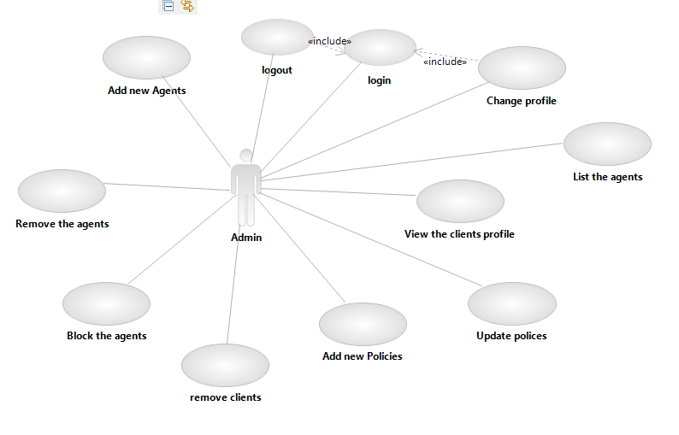

1. **Admin:** Admin can do each and every task in the system. The basic tasks of him/her are view customer details, create, update, list & delete agents, view agent details & create new agent login.
2. **Agent:**  Agent is the one who make the verification of customer at different levels according to the different type of insurance product for which the customer is applying.
3. **Customer:** Customer is the one who interact with the agent for application and activation of the insurance plan. His/her basic tasks are applying for the insurance product and see the status through the web portal, make premium payments etc.

**CONCLUSION AND FUTURE WORK** The Insurance Agent Samurai System is a better way to store the information about customer, his/her policy illustration and ease to process his/her policy activations contract while taking a policy. The system also include some components like adding agent, policy, listing agents, see illustration ,register etc. to make it features app. We can conclude that:

1. The system brings transparency in handling the customer request.
2. Friendly & interactive environment for users.
3. Since it’s a web application it can be used by different users simultaneously on different systems.
4. Policy illustration and agent handling is a special feature of this web application.
5. It reduces a lot of paper work and time.

**FUTURE SCOPE OF THE SYSTEM**

1. In future an Android, iOS and Windows application can be develop for a customer to track status of his policy without going or calling to the agency.
2. It’s also possible to convert the system into a management system as different managements are already present in the system.
3. Multithreading can be used to increase the performance of the system.
4. Predefined format of report can be added in the system.
5. Make system so efficient and light that it can open on mobile or tablet easily.
6. Security of the system can be improved by applying different encryption and authentication techniques.